What makes good evidence?
Once a setting has registered and is logged onto their online portal for Healthy Tots, they will be able to see all the different criteria points which need to be evidenced in order to complete the award. We have provided a couple of additional descriptions to help settings to get started!
Below are some examples of documents which would help to support your settings evidence:
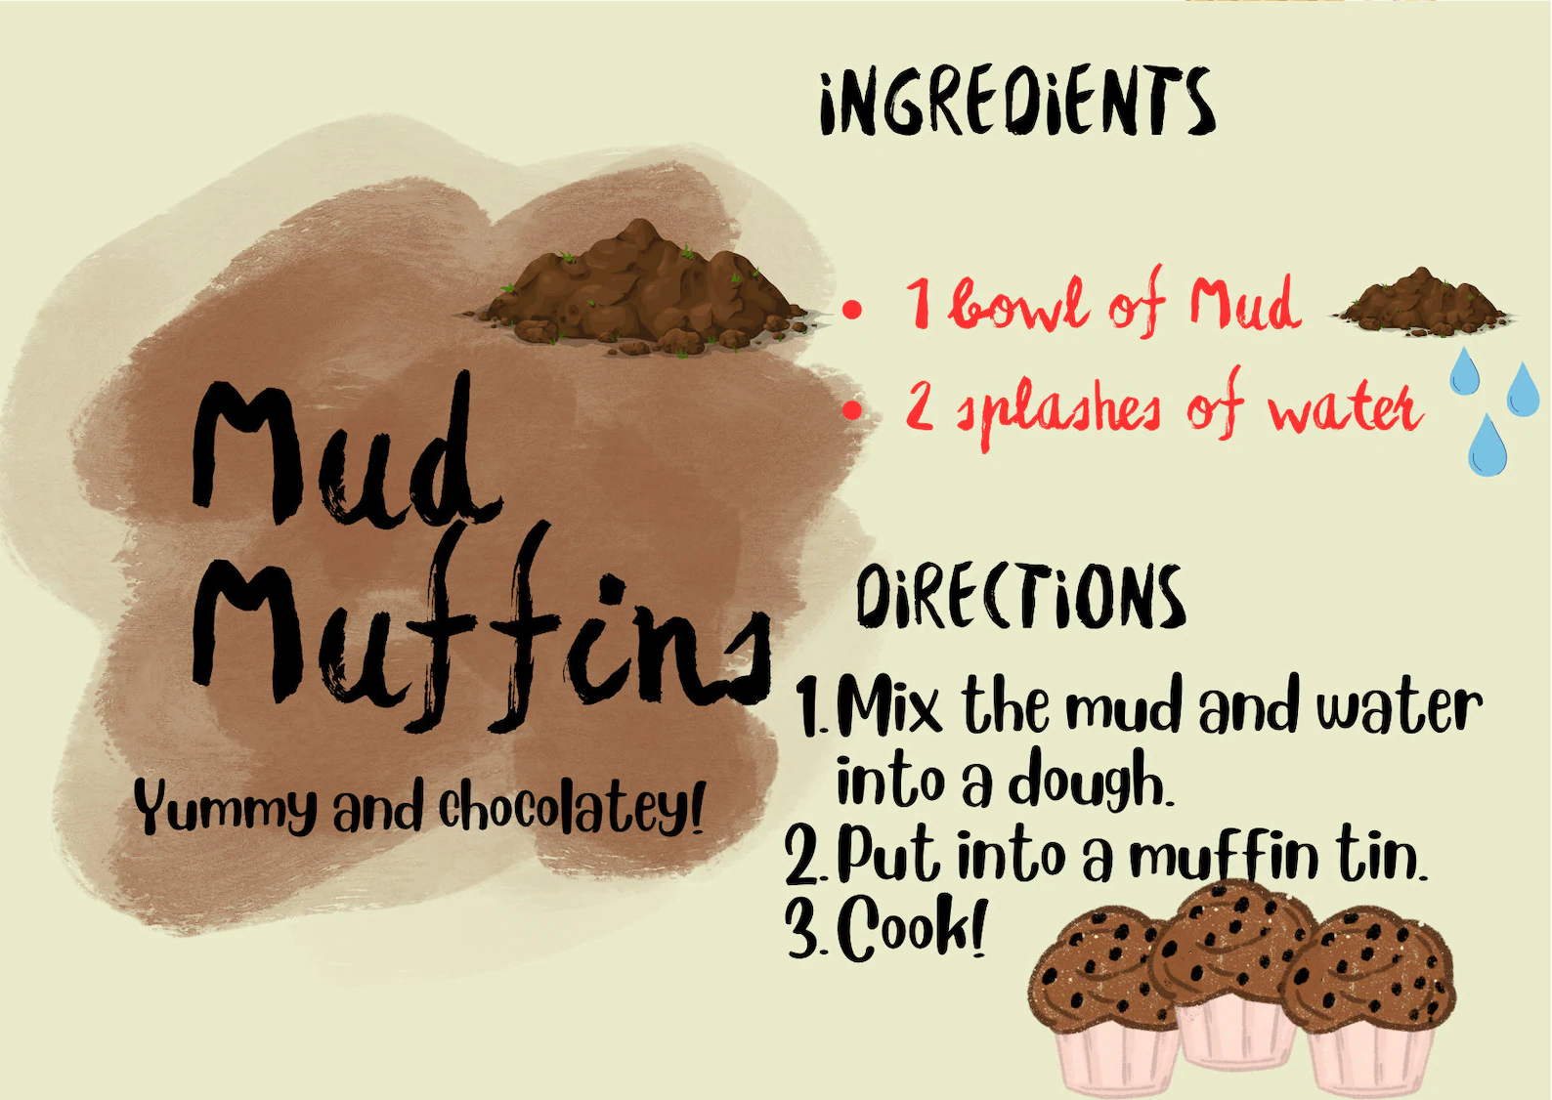
- Policies
- Leaflets
- Supervision records (anonymise where possible)
- Children’s observations (anonymise where possible)
- Parent feedback sheets
- Setting questionnaires
- Screenshots of social media posts
- Photographs of display boards, equipment set out for an activity, parts of a policy or other documents
PLEASE NOTE – if you choose to upload photographs of children taking part in activities please ensure you:
- Always gain consent, or blur out the faces/show activity without faces – see opposite
This Photo by Unknown Author is licensed under CC BY-NC
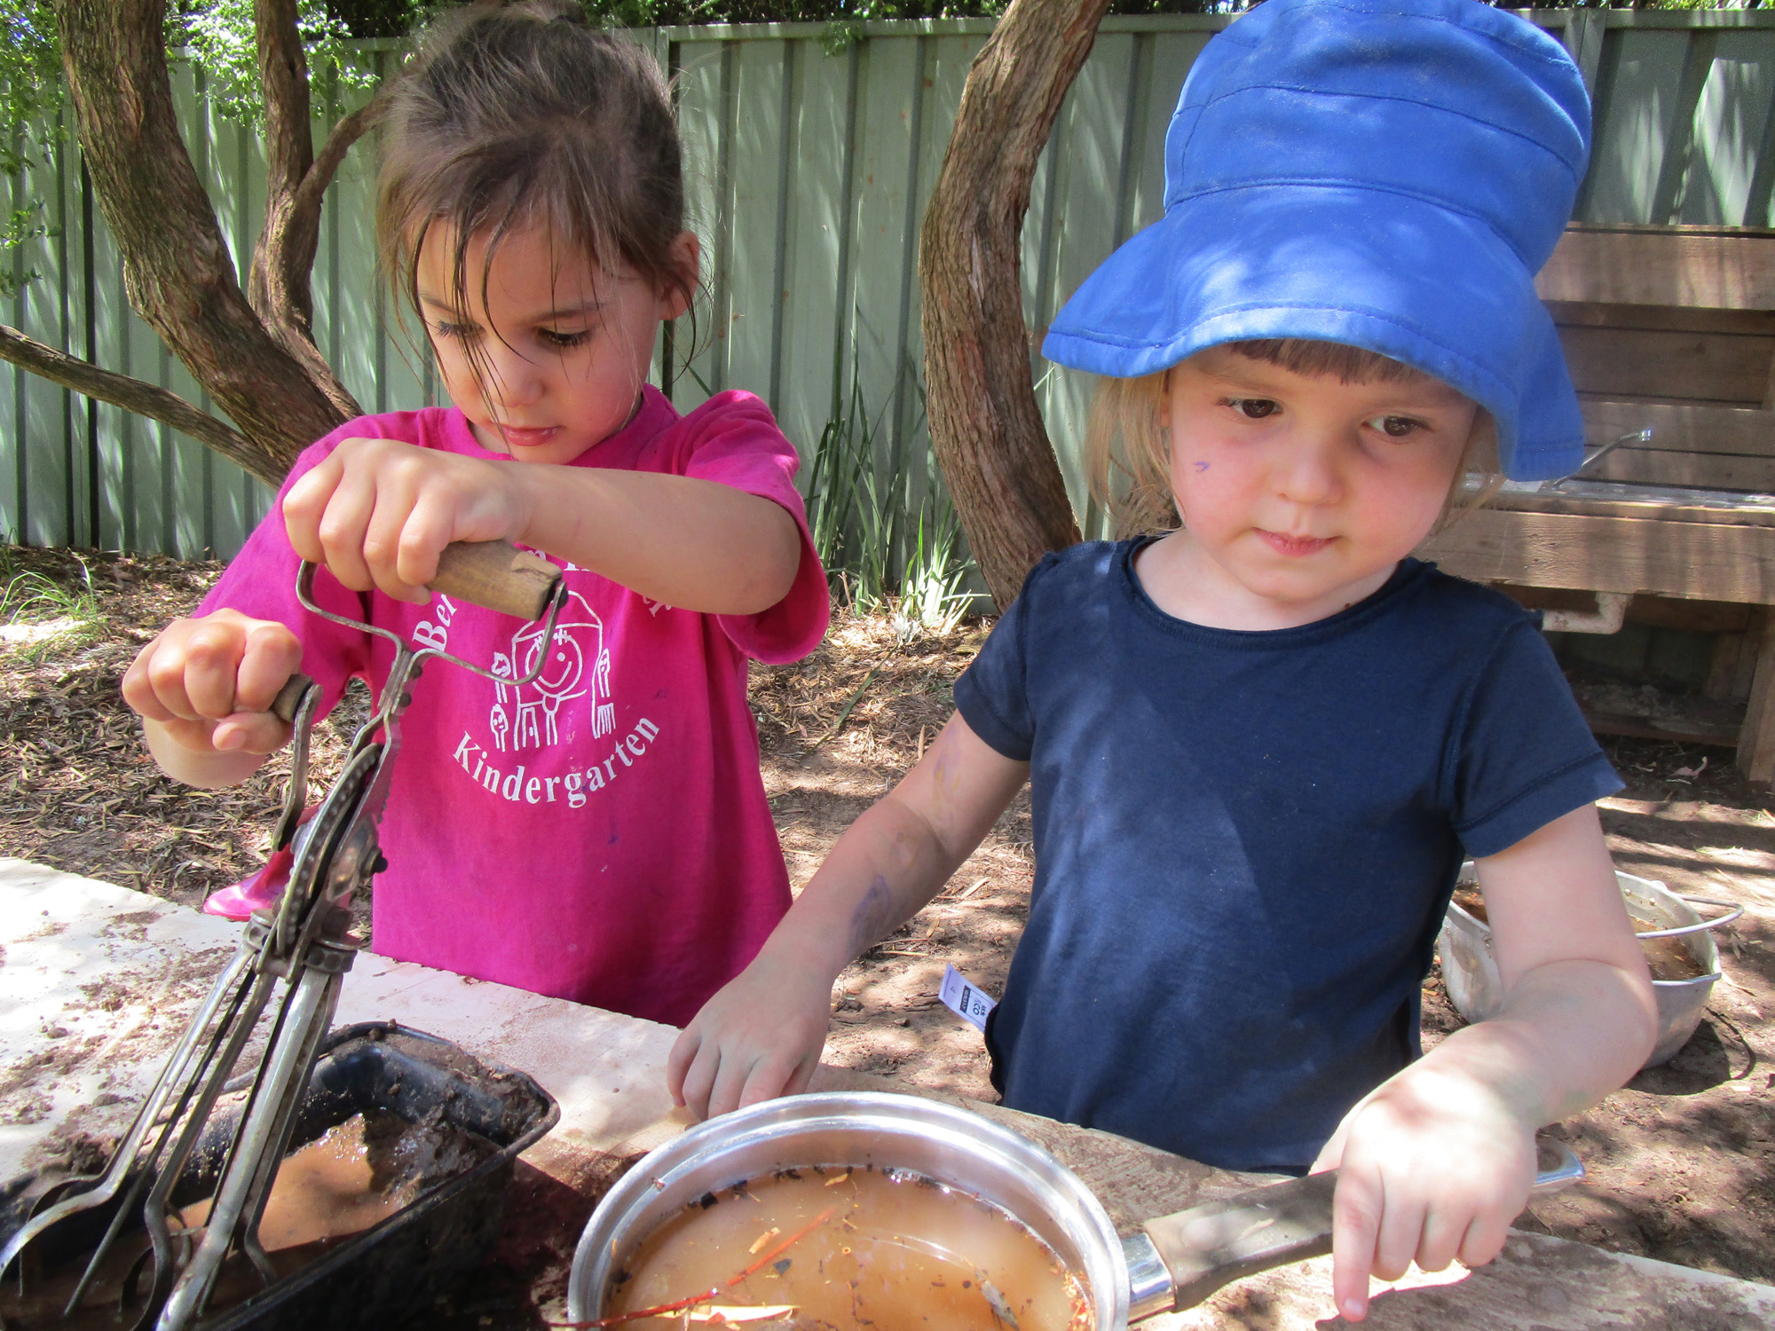
Comments box
- Use the comments box to describe how your settings meets the criteria. Descriptions and examples are extremely powerful and can really showcase some of the amazing work which will be taking place at the setting.
- If you choose to upload an attachment, please ensure you tell us what it is and how it meets the criteria.

Below is an example of how a setting may evidence– Physical Activity point 6.1 - Physical activity is creatively embedded into daily activities throughout the setting”
“I have attached a photograph showing two children at our setting engaging in physical activity outdoors. We plan physical activities everyday and ensure this is in line with the EYFS framework, but we also provide opportunities for children to direct and guide their own learning by providing resources that are available continuously. The children in the photograph are playing and exploring in our mud kitchen that they have access to everyday. On this occasion the children decided they were making porridge for the three bears after hearing the story, they had said it was very tiring making different bowls of porridge for the bears, especially for big bear and wanted to keep mixing it up so there were no lumps!
This was a spontaneous activity which the children were developing lots of fine and gross motor skills as part of their physical development by what turned into an incredibly fun physical activity!
In our Baby room (6 months – 20 months); when our babies are not yet crawling, we encourage them to be physically active by reaching for objects, grasping, pulling or pushing themselves along, moving their head, body throughout daily routines and we also give them supervised floor play; Tummy time is offered also throughout the day. Once our babies are moving, we then try to encourage and help them to be as active as possible throughout the day whilst in a safe and supervised environment”.

How to cross reference different criteria points using the same evidence
“The second attachment is a post we sent out to the parents explaining that they could create a mud kitchen with a few simple things that also don’t cost a lot of money.. This links to 3.1 Parents/carers are encouraged to engage with the setting in relation to physical activity.
Both attachments link to 6.4 (Emphasis is placed on outdoor physical activity and learning) and that the setting recognises the importance of outdoor play”

